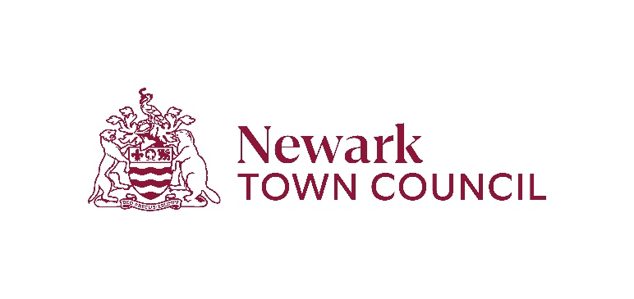

# Equality and diversity monitoring form

**Newark Town Council** wants to meet the aims and commitments set out in its equality policy. This includes not discriminating under the Equality Act 2010 and building an accurate picture of the make-up of the workforce in encouraging equality and diversity.

The Council seeks your help and co-operation to enable it to do this but filling in this form is voluntary. The information will kept separate from your application and will form no part of the selection process.

**Gender** Man 🗆 Woman 🗆 Intersex 🗆 Non-binary 🗆 Prefer not to say 🗆 If you prefer to use your own term, please specify here …………………….

**Are you married or in a civil partnership?** Yes 🗆 No 🗆 Prefer not to say 🗆

**Age** 16-24🗆 25-29 🗆 30-34 🗆 35-39🗆 40-44 🗆 45-49 🗆 50-54 🗆55-59 🗆 60-64 🗆 65+ 🗆 Prefer not to say 🗆

**What is your ethnicity?**

Ethnic origin is not about nationality, place of birth or citizenship. It is about the group to which you perceive you belong. Please tick the appropriate box

***White***

English 🗆 Welsh 🗆 Scottish 🗆 Northern Irish 🗆 Irish 🗆

British 🗆 Gypsy or Irish Traveller 🗆 Prefer not to say 🗆

Any other white background, please write in:

***Mixed/multiple ethnic groups***

White and Black Caribbean 🗆 White and Black African 🗆 White and Asian 🗆 Prefer not to say 🗆 Any other mixed background, please write in:

***Asian/Asian British***

Indian 🗆 Pakistani 🗆 Bangladeshi 🗆 Chinese 🗆 Prefer not to say 🗆

Any other Asian background, please write in:

***Black/ African/ Caribbean/ Black British***

African 🗆 Caribbean 🗆 Prefer not to say 🗆

Any other Black/African/Caribbean background, please write in:

***Other ethnic group***

Arab 🗆 Prefer not to say 🗆 Any other ethnic group, please write below:

**Do you consider yourself to have a disability or health condition?**

Yes🗆 No 🗆 Prefer not to say 🗆