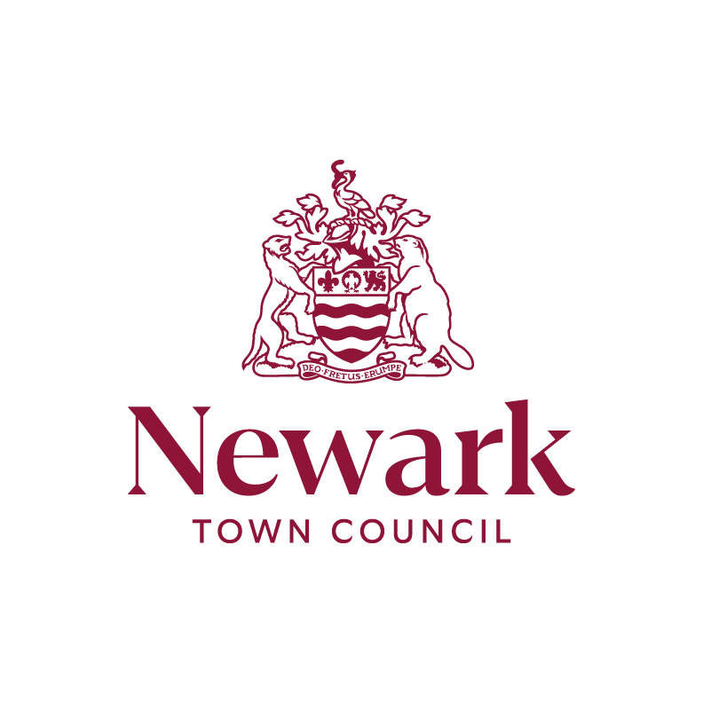

Community Grants Policy
October 2024

Community Grants Policy

Contents
Part A - Policy 3

Priorities 3

General information for applicants 3

Who is eligible to apply 3

Who and what is not eligible to apply 4

What can be funded 5

The following are unlikely to be considered a grant priority 5

Conditions of grant 5

Part B – Applications guidelines & procedure 7

Preparing your application 7

How to apply 7

How decisions will be made 7

What happens next 7

Document History
Adopted by Council – 4 December 2017
Reviewed & Adopted – 9 July 2024
Updated & Adopted – 8 October 2024

Part A
Policy
This policy’s purpose is to highlight to applicants Newark Town Council’s grant funding procedure and to act as a point of reference for councillors when reviewing applications.

To ensure that fair and proper consideration can be given to all requests, the Council requires a fully completed application form to be submitted to the Town Council either through the online application form, via email or through the post.

If the organisation is a new entity with no accounts available, please provide a brief overview of what your organisation/project is, your aims and objectives and why you’re seeking funding, where this is not possible applicants should seek advice from the Town Clerk. Award of the grant shall be by discretion of the Council.

Priorities

The priorities in awarding grants are set out below:

To benefit communities in the Parish of Newark by supporting organisations and projects which help to improve safety, recreation, education, community pride, sports, art and culture.

General information for applicants

Grants are available up to £500.00 and the amount awarded will be determined by the Town Council. At our discretion we will award a sum greater than £500.00 if financial resources allow and we view the grant applications as having merit.

Who is eligible to apply

The following organisations may apply to the Town Council for a Community Grant:
a. A Newark Town based charitable and/or non-profit making organisations.
b. Citizen(s) of Newark requesting grant aid with a project/event, which will be for the benefit of the local community
c. A Newark based club/association/charity/sports club serving a specific section of the community or the community as a whole. The more socially inclusive groups will be more likely to be successful in their applications.

While it is the Town Council’s policy to give preference to groups/organisations/projects which are Newark based, applications may also be considered from:
a. An organisation/group, local, regional or national which serves the needs of the town.
b. A local branch of a regional or national organisation/group which serves the needs of the citizens of Gainsborough.
c. An organisation/group (local, regional or national) arranging a project which will be accessible and beneficial for the citizens of Newark.

To be eligible for a Community Grant an organisation must:

- Be established for charitable, benevolent, social, cultural, recreational or philanthropic purposes with a clearly stated social ambition for the community of Gainsborough.
- Be able to provide a copy of its latest annual accounts and most recent bank statement.
- Have a bank account operated by a minimum of at least two joint signatories.
- Where appropriate, be able to demonstrate that Child and Vulnerable Adult Safeguarding measures are in place. This will be usually in the form of an appropriate policy that requires those working directly with children and vulnerable adults to be DBS checked and approved.

Applications do not have to be from groups that already exist but, in such circumstances, the Council will need to be satisfied as the manner in which any project for which a Community Grant is sought will be delivered and may impose additional conditions on any grant awarded or delay the award until the project has been completed.

The application must be made on the official application form and must be returned to the Town Council either by submitting through the online application form, via email or if by post by the deadlines: The deadline for receipt of applications is:
- 28th February (for determination in March)
- 31st May (for determination in June)
- 31st August (for determination in September)
- 30th November (for determination in December)

The Finance and Strategy Committee will decide who the successful applicants are and thereafter the Community Grant will be awarded.

Who and what is not eligible to apply

We will normally reject applications from:

- Projects which are the prime statutory responsibility of other government bodies or would normally be funded by a local or regional authority
- Projects which improve or benefit privately owned land or property
- Support for private business projects
- Applications by “for – profit” commercial organisations
- Projects which have already been completed or will have been by the time the grant is issued
- From regional and national organisations unless it can be clearly demonstrated that the grant would be used specifically for the residents served by Newark Town Council.
- From organisations with political affiliations or those established for the purpose of forwarding a party-political agenda.
- National appeals are, with limited exceptions, regrettably outside the legal scope of the Council’s grant-aid scheme

What can be funded

The project should be something that makes the local community a better place in which to live, work or visit it should be something that will provide a long lasting and sustainable benefit to our local area.

Projects may be funded if one or more of the following criteria are met:

- It should benefit people who live in Newark – i.e. your event/project is based within a DN21 postcode, it is accessible to anyone in Newark or is tailored to a specific target audience in the local area (i.e. a children’s group).
- It must be sustainable in the longer term
- It should engender a sense of civic pride

Additionally:
- New or informal groups of people who have formed to undertake new projects - priority will be given to those who are doing something which adds value (i.e. improving facilities), rather than applications for running costs.
- Priority will be given to applicants who have not previously received grants from Newark Town Council previously.

The following are unlikely to be considered a grant priority

- Projects that simply replace existing facilities with no significant improvement
- Projects where there is a large shortfall in the funding required to complete the project will be reviewed differently. We may put forward an offer of a grant on the condition you receive the other funding within six months – please note, this money will not be sent through until we have evidence of other successfully awarded grants.
- However, all grant applications will be considered on their own merits.

Conditions of grant

- Newark Town Council support must be acknowledged as appropriate on all publicity and promotional material including posters, advertisements, press releases and leaflets.
- Newark Town Council can name your organisation on its own publicity of the grant awarding, including presentations, press releases, website content and social media posts (please note this is not an exhaustive list of all potential uses).
- Financial support can only be used for the purpose for which the Community Grant is given, and as such we consider our grant to be registered as “Restricted Funding”. Failure to adhere to this condition could lead to the cancellation or reduction in the value of the grant.
- Grants must be used within 12 months of the date of the Grant payment.
- Grants will only be awarded for forthcoming projects – not retrospectively.
- The Council reserves the right to request a copy of invoices and/or other documentation as evidence that the expenditure has been incurred.
- If an organisation dissolves and the grant has not been spent the Council would expect the organisation to reimburse the grant-aid awarded.
- Organisations are not restricted to the number of grant applications submitted to the Council for grant-aid over a period of time, however the history of previous applications will be considered in the decision-making process.
- The giving of a grant one year does not set a precedent for another year.
- Grants must not be distributed to any other organisation.

Applications forms are available from:
Newark Town Council, Town Hall, Market Place, Newark, NG24 1DU
Tel. No. 01636 684806

Part B – Applications guidelines & procedure

Preparing your application

How to apply

Complete the application form

Submit completed application form along with all relevant additional information requested in 4.3 to the Town Council.

How decisions will be made

We may not be able to fund all projects as there may be more applications than money available. All applications will be considered but you may not receive the full amount of grant you apply for.

The application will be assessed initially by the Council based on the following criteria: -

- General eligibility
- Impact on key local need
- Community support
- Value for money
- Environmental impact
- Community involvement
- Feasibility
- Likely effectiveness

The decision of the Town Council is final, and the Council will not enter into correspondence concerning the assessment of the grant.

What happens next

- If your application is successful, you will be sent an email or a letter informing you. Included with this will be an acceptance form and the terms and conditions of funding. You need to read these, sign the acceptance form and return it to us.

- If you are unsuccessful, we will write to tell you so.

- In certain circumstances, we may ask you to meet other conditions before we issue your grant.

- When your project is finished, we will ask you to provide copies of invoices related to the project, if your grant has not been used for the purpose specified on your application, the Council may request the funds are returned in full

Newark Town Council reserves the right to vary the application of this policy in circumstances where significant benefit to the town is demonstrated.

