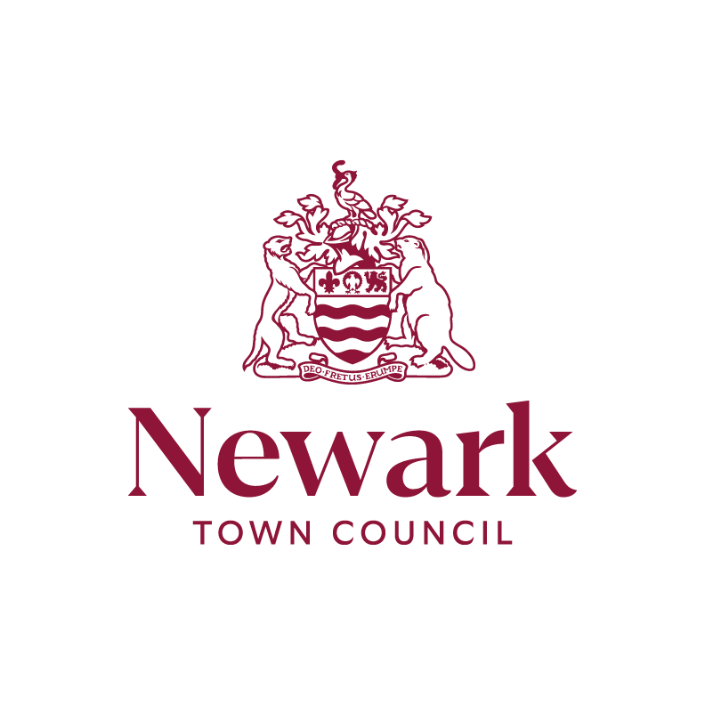

WELCOME TO NEWARK ROYAL MARKET

Unless already agreed with us, to Trade on the Newark Market, we require:

- A completed Trader Registration Form –fill in on the day
- Proof of ID of name and address and photo- EG: DRIVING LICENCE
- Public liability insurance cover certification minimum £2 million
- FOR FOOD SALES: Food Safety scores and if available- registration

Drive to the marketplace (NG24 1DU) via Kirkgate and Church Street from 8.00 am onwards with your vehicle. The bollard outside the Church should be down, if not please use the intercom in the side pillar.
To exit the marketplace, you do this via stodman street, this is once again a rising bollard which lowers once the car reaches a certain point. Please wait until the light on the bollard on the right side turns green before proceeding.

Please attend the market office (first door on right down the alleyway between Nat West Bank and the Town Hall) or lookout for one of the team in maroon clothing, who will allocate and show you to your stall; advise you re: parking permit for your vehicle for the day and answer and deal with any questions/requests you may have. They are here to help you! You will be advised where to park. Ask an adjoining trader/market staff to look after your stall we are here to help each other to succeed.

Trading is 09.00 am – 15.00 pm. Newark Town Centre is pedestrianised between the hours of 10am and 4pm so no vehicles on the market unless authorised by market staff.

Toilets are available - St marks toilet which is through the alleyway across from Boots Opticians (free to all traders). There are also toilets at Riverside Park (free to everyone) and also at the Lorry Park (free)

We provide free parking at Newark Lorry Park, which is approx. 15min from the market place, we just need your vehicles registration. There are other options available but these are pay and display car parks further info regarding these is available on Newark and Sherwood District website
https://www.newark-sherwooddc.gov.uk/your-district/your-district/car-parks/

We don’t like plastic and are aiming to reduce as much plastic on the market as possible- please do all you can to minimise its use

We want to help you promote your goods- please let us have any promotional material for us to share on our social media sites- send to anna.lawson@newark.gov.uk

There is also an amazing guide on the National Market Trading Federation website.
https://www.nmtf.co.uk/info/sim/
This guide gives advice for new and old traders on how to make first impressions, social media, making signage work for you amongst other brilliant advice.
Quite a few businesses have difficulties in the first 6 months due to various reasons, but this guide is a fountain of knowledge. Also, the market team has years of experience and are only willing to offer there help and support to all. We want you to succeed.

We also would love to get to know yourselves/your business so we have a basic questionnaire to do this, and it would be appreciated if you could fill in and return it to us.

Wishing you a long and successful trading experience at NEWARK ROYAL MARKET
If you have any questions, please let us know

Market Staff Contact Details:

Market Office gary.hill@newark.gov.uk or michael.creamer@newark.gov.uk
Tel: 01636 681 497

Alexe Crawford, Senior Administration Officer- alexe.crawford@newark.gov.uk
Tel: 01636 684 804

Questionnaire

Any Previous Market Trading Experience?

What Products Do You Sell?

Any social media Sites?

What Levels of Pricing Intended?

Do you have any specific areas where you might need extra support from us?

Have you any Questions for us?

